2303A52406
Batch-38

LAB_ASSIGNMENT-6.2

Task Description-1 (Classes – Data Validation)
• Prompt AI to generate a Student class with attributes: name,
roll_no, and marks. Add a method is_pass() that returns whether
the student has passed (marks ≥ 40).
Expected Output-1
• Python class with constructor and validation logic
• Clear method implementation returning pass/fail status
• Students analyze correctness and clarity of class design

Prompt:
give a python code o generate a Student class with attributes: name,
roll_no, and marks. Add a method is_pass() that returns whether
the student has passed (marks ≥ 40).
and give output with these constraints:
• Python class with constructor and validation logic
• Clear method implementation returning pass/fail status
• Students analyze correctness and clarity of class design

Code:
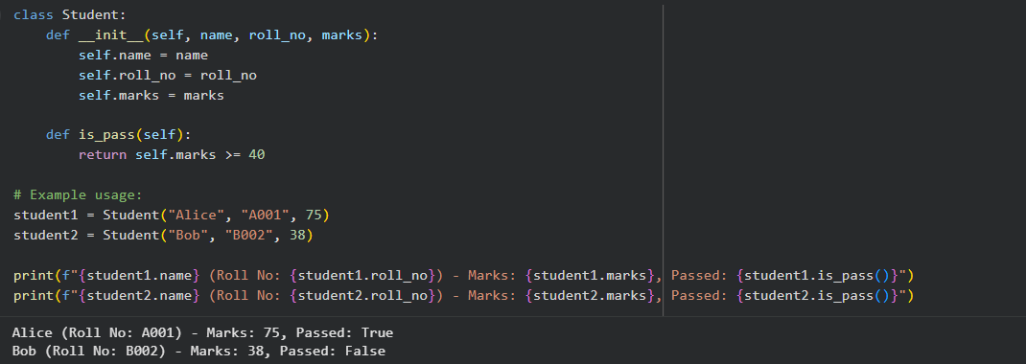

Explaination:
This code is basically a blueprint for a student, storing their name, roll number, and marks.
When a student object is created, it checks that all the details make sense, like valid marks and a proper name.
It also has a simple check to tell whether the student has passed by seeing if their marks are at least 40.

Task Description-2 (Loops – Pattern Generation)
• Ask AI to generate a function that prints a right-angled triangle
star pattern using a for loop. Then regenerate the same pattern
using a while loop.
Expected Output-2
• Correct pattern output using both loop types
• Logical loop structure with proper conditions

Prompt:
give python code to generate a function that prints a right-angled triangle
star pattern using a for loop. Then regenerate the same pattern
using a while loop.and give output with these constraints:
• Correct pattern output using both loop types
• Logical loop structure with proper conditions

Code:
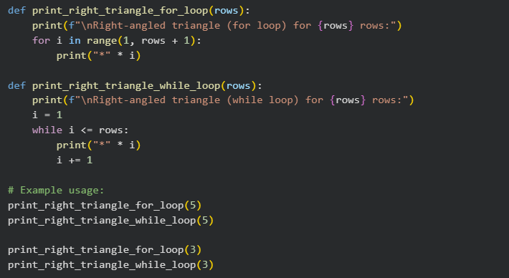

OUTPUT:
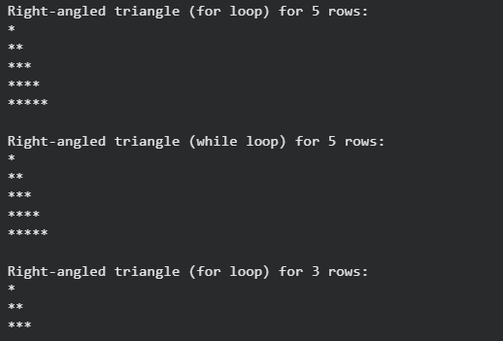
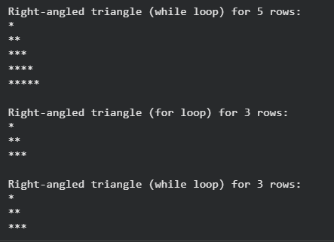
Explaination:
This code prints a right-angled triangle made of stars, with the number of rows decided by the value of n.
One function uses a for loop, increasing the number of stars on each line step by step.
The second function does the same thing but uses a while loop instead.
In the example, n is set to 5, so both methods print a triangle with five rows of stars.

Task Description-3 (Conditional Statements – Number Analysis)
• Ask AI to write a function that checks whether a given number
is positive, negative, or zero using if-elif-else. Test the function
with multiple inputs.
Expected Output-3
• Function correctly classifies numbers
• Proper handling of all conditions
• Students analyze decision logic

Prompt:
give python code to write a function that checks whether a given number
is positive, negative, or zero using if-elif-else. Test the function
with multiple inputs. and give output with these constraints
• Function correctly classifies numbers
• Proper handling of all conditions
• Students analyze decision logic

Code:
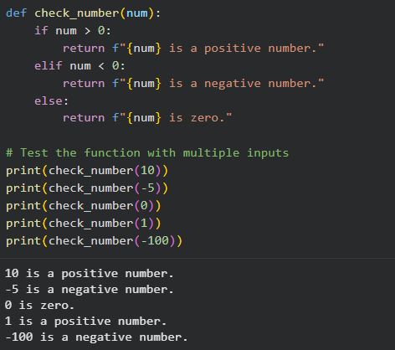

Explaination:
This code defines a function that checks whether a number is positive, negative, or zero.
Inside the function, simple if, elif, and else conditions are used to compare the number with zero.
The function then returns a text result based on that comparison.
In the main part of the program, a list of different numbers is created for testing.
Each number is checked one by one, and the result is printed in a clear, readable message.

Task Description-4 (Nested Conditionals)
• Generate a function check_discount(age, is_member) that
determines discount eligibility:
• Age ≥ 60 → Senior discount
• Member → Additional discount
Use nested if statements.
Expected Output-4
• Python code using nested conditionals
• Clear explanation of decision flow

Prompt:
write a python code to Generate a function check_discount(age, is_member) that
determines discount eligibility:
• Age ≥ 60 → Senior discount
• Member → Additional discount
Use nested if statements.and the output should be with these constraints:
• Python code using nested conditionals
• Clear explanation of decision flow
Code:
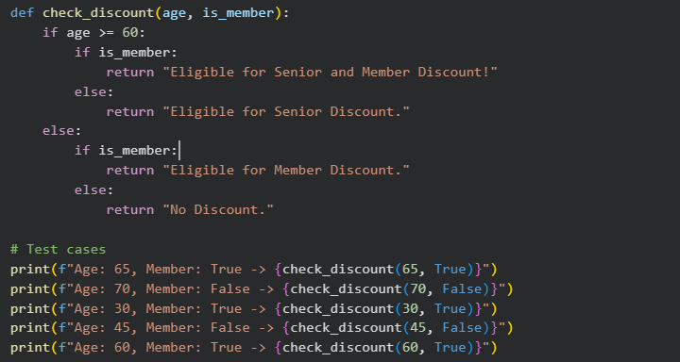
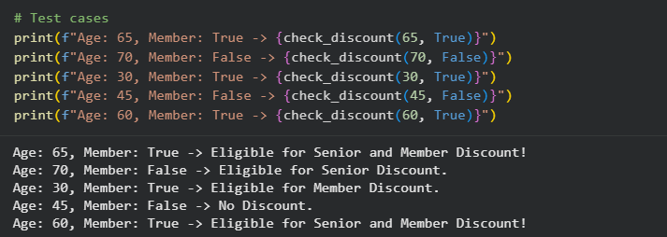

Explanation:
This code checks what kind of discount a person can get based on their age and whether they are a member.
If the person is 60 or older, the code considers them a senior and checks for extra member benefits.
For people under 60, it only checks whether they are a member or not.
Based on these conditions, the function returns a clear message about the discount eligibility.
The example calls show how different ages and membership statuses lead to different results.
Task Description-5 (Class – Mathematical Opera)
• Ask AI to create a Circle class with methods to calculate area ()
and circumference () given the radius.
Expected Output-5
• Correct mathematical computation
• Well-structured class with methods
• Code explanation provided

Prompt:
write a python code to create a Circle class with methods to calculate area ()
and circumference () given the radius.
Expected Output-5
• Correct mathematical computation
• Well-structured class with methods
• Code explanation provided

Code:
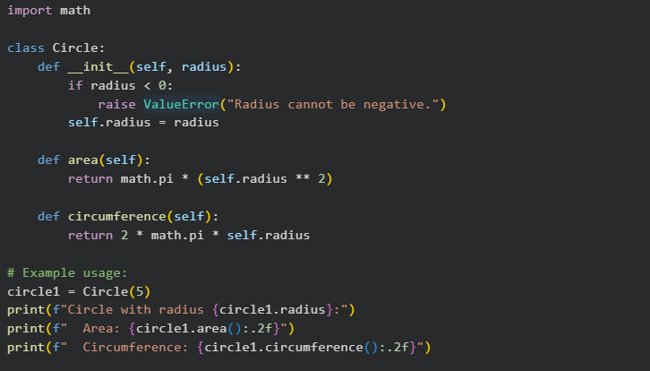
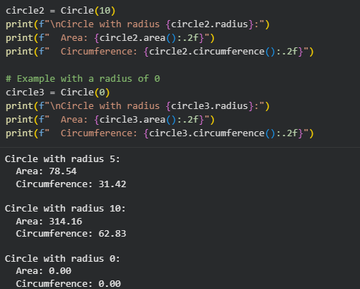
Explanation:
This code defines a Circle class that represents a circle using its radius.
When a circle object is created, it checks that the radius is not negative before saving it.
The area method calculates the area of the circle using the mathematical formula π × r².
The circumference method calculates the distance around the circle using 2 × π × r.
In the example, a circle with radius 5 is created and its area and circumference are printed neatly.

